## CPH -IVT User shall be able to search for Health Indicator Data by U.S. Census Division

|  |  |  |
| --- | --- | --- |
|  | | |
| **Requirements ID:** REQ0002-SearchByRegion | | |
| **Primary Actors:** User, CPH-IVT | | |
| **Use Case Name:** Search by Region | | **Importance Level:** High |
| **Stakeholders:** | Users, Admin, developers | |
| **Requirement:** | The user shall be able to search for Health Indicator Data (HID) by U.S. Census Region | |
| **Story:** | As a User, I want to be able to search HID by U.S. Census Region, so I can see HID by that region | |
| **Quality Requirements:** | The Admin shall be able to search U.S Census Regions in sixty seconds or less. | |
| **Pre-Conditions:** | 1. I am a User 2. I have logged into the CPH-IVT program | |
| **Post-Conditions:** | Success:   1. I am able to search by U.S Census Region   Failure:   1. I am not able to search by U.S Census Region | |
| **Relationships:** | None (This requirement is atomic) | |
| **Trigger:** | **Trigger Type:** External  I request the Search by Division at <host> | |
| **Normal Flow of Events:** | 1. CPH-IVT displays the regions page   2. I select Region I want to get Health Indicator Data for  3. CPH-IVT displays HID for selected region | |
| **Exception flow** | [ICPH-IVT does not have HID information for Region]   1. CPH-IVT displays the region page 2. I select RegionI want to get Health Indicator Data for 3. CPH-IVT is not able to display HID for selected region | |
| **Storage Requirements** | **Host**  <host>:: not assigned at present time  **Login Credentials**  <login credentials>:: <ETSU email>|<username><tab><password>  <ETSU email>:: [a-z]+[0-9]*@etsu.edu  <username>:: [a-z]+[0-9]* <password>:: 8{[A-Z]+[a-z]+[\d]+[@$!%*?&]+)}24 | |

**Behavioral Flow**

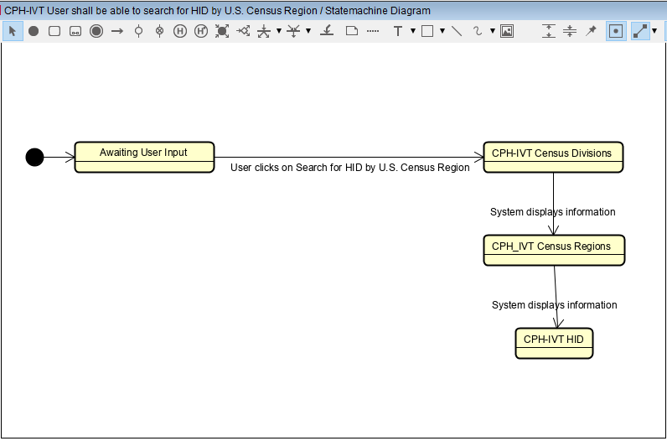

**Data Elements**

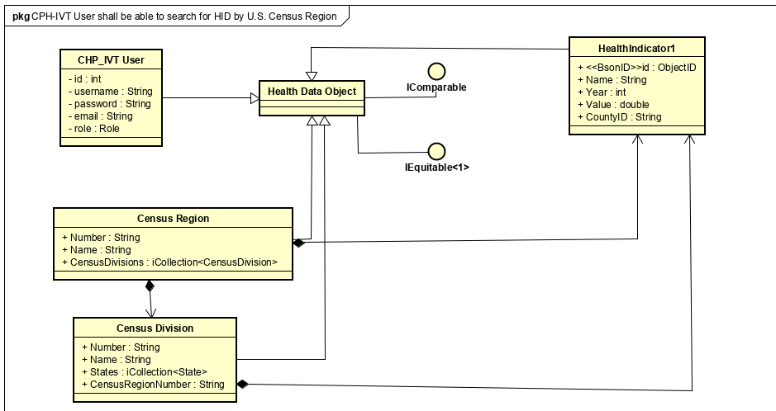

**UI Template**

